RESOLUTION NO.__________

RE: CERTIFICATE OF APPROPRIATENESS UNDER THE
PROVISIONS OF THE ACT OF THE PENNSYLVANIA
LEGISLATURE 1961, JUNE 13, P.L. 282 (53
SECTION 8004) AND BETHLEHEM ORDINANCE NO.
3952 AS AMENDED.

WHEREAS, it is proposed to install a canopy mounted sign and a flag mounted sign on the structure at 324 S. New Street.

NOW, THEREFORE, BE IT RESOLVED by the Council of the City of Bethlehem that a Certificate of Appropriateness is hereby granted for the work.

Sponsored by: (s)

(s)

ADOPTED BY COUNCIL THIS DAY OF

(s)
President of Council

ATTEST:

(s)
City Clerk

HISTORIC CONSERVATION COMMISSION

CASE # 630– It is proposed to install a canopy mounted sign and a flag mounted sign on the structure at 324 S. New Street.
OWNER/APPLICANT: Bethlehem Parking Authority / Kevin Livingston

The Commission upon motion by Mr. Silvoy seconded by Mr. Evans adopted the proposal that City Council issue a Certificate of Appropriateness for the proposed work described herein:

- The proposal to install a canopy mounted sign and a flag mounted sign on the structure at 324 S. New Street was represented by Kevin Livingston, Kevin Wenck and Ed Flowerdew.

- The canopy sign will consist of 12” h x 1” thick FCO (Full Cut Out) aluminum letters welded to a bottom mounting rail. It will read “NEW STREET PARKING GARAGE”.

- The “flag-mounted” sign will be 120” high x 52” wide. The thickness of the sign cabinet will be reduced to 9”. The topper and footer will project an additional 2”-3” on each side.

- The sign will have 1” thick FCO aluminum letters mounted to .125” thick charcoal color aluminum faces.

- The sign will be supported by 6x6 square steel tube structures with 12”x 12” steel mounting plate for through-bolting to the brick façade.
- Two gooseneck lights in charcoal color will be installed to light the projecting sign.
- The motion to approve the proposed work was unanimously approved.

CU: cu
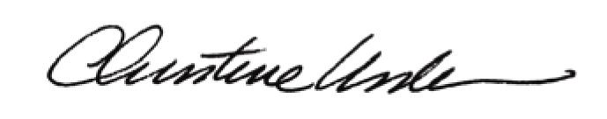

By:

Date of Meeting: October 16, 2017 Title: Historic Officer

